*PACKET SNIFFER*

**Detailed Project Description :**

While diagnosing the underlying problems of a network, we may want an essential tool that aids in monitoring network traffic and troubleshooting a network. Packet sniffer is one such tool.

Our project focuses on capturing and analyzing packets of data that flow through a particular network.

Packet sniffer can be hardware device or software application. Our development tool is a software application. This tool runs on standard general-purpose computers performing packet sniffing tasks by using the hardware capabilities of the network.

This tool allows the user to be able to view Source of the packets and display the target host and the type of protocol used like UDP OR TCP.

Various transport layer protocols like TCP, UDP, are implemented for analysis.

packet sniffers are used to troubleshoot and rectify network-related problems.

**Monitoring network usage** – Packet sniffers are great at monitoring the network usage at any given time, helping Network Managers identify whether a particular network is normal or congested. Also, making it possible to identify bottlenecks within the network and identify and improve the performance with infrastructure upgrades.

**Identifying problems** – As mentioned earlier, packet sniffers can identify network-related issues. This is possible because a packet sniffer can analyze the conversation between two or more nodes in a network. So, in the event of a network error, the information captured by the packet sniffer can be used to identify the erroneous packets and pinpoint the node that failed to answer the request(s). Making it easy to identify faulty devices within the network in an efficient manner and providing the ability to take swift corrective actions.

**Detecting security loopholes** – A disturbing fact about packet sniffers is their ability to work as spying tools. They also help the good guys, such as your Network Manager, by testing the vulnerabilities of a network. Once these vulnerabilities are detected, it is easier to remove the loopholes thus preventing the possibilities of hacking attempts.

**Description of Working Procedure with algorithm** :

A packet sniffer can view a wide variety of information that is being transmitted over the network as well as the network it is linked to. Packet sniffers exist in the form of software or hardware and can capture network traffic that is both inbound and outbound and monitor password use and user names along with other sensitive information. A packet sniffer allows you to set the interface of the network to view all of the information that is transmitted over the network. **When the data passes through the system, it is captured and stored in memory so the information can be analyzed.**

The packet sniffer gets its name from normal computer usage where the individual computer inspects packets of data that match the address of the computer. However, with a packet sniffer, **it can examine all of the incoming data from all of the computers** **that are connected to the network** by viewing every packet that is sent over the network. A packet sniffer that has been installed on the network is capable of examining all of your email contacts, email messages, downloaded files, websites you visited, and all of your audio and video activity.

We know that data travels through a network in the form of packets. **In packet-switched networks,** the data to be transmitted is broken down into several packets. These packets are reassembled once all the data packets reach their intended destination.

When a packet sniffer is installed in the network, the sniffer intercepts the network traffic and captures the raw data packets. Subsequently, the captured data packet is analyzed by the packet sniffing software and presented to the network manager/technician in a user-friendly format. By user-friendly, we mean the Network Administrator should be able to make sense of it.

Here we used the python network programming library “socket” to intercept the network traffic, we then have written user-defined functions to unpack the data, format the data, fragment and assign the values of respective data packet to the right variables which facilitates proper display of the packet data being sniffed and helps is further analysis of the data packet.

How the code works:

1. **SNIFFING** by using a)SOCKET() system call.(practically All the sniffing is done here).

b)recvfrom loop is used to receive data (input).

The buffer will hold the data sniffed

1. **read the captured packet**

**icmp_packet(data): ICMP** packets can be analysed by **capturing the packet and validating it and filtering is done based on the protocol used.**

So we developed different protocol functions like ICMP, TCP (HTTP), UDP, others(IPV4).

1. **analyse it**

**Our packet sniffer tool can sniff TCP,UDP,ICMP and IPv4 packets by unpacking the structure and matching the raw data with the protocol segments.**

**When code breaks the input into different sections and unpacks them, it’s analysis looks like this.**

1. **present it to the user in a readable format.**

* **Unpack Ethernet Frame : struct.unpack()**
* **Format MAC Address :**
* **Unpack IPv4 Packets Received : struct.unpack()**
* **In the same way unpacks and formats for TCP, UDP, ICMP packets using struct.unpack().**

**Flowchart (or block diagram)**:

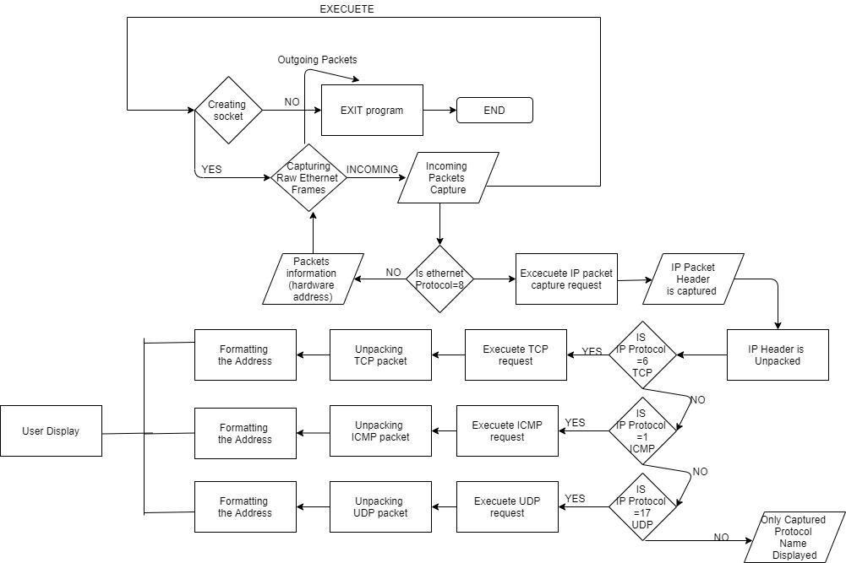

**Implementation**:

Requirements :

* Python 3.x
* Privileged/Administrative Rights
* Linux or Windows Operating System.

We have implemented the above described working procedure using the following library and functions:-

**Import functions:**

example socket() : the **socket()** function returns a socket objec*t* whose methods implement the various socket system calls. Packet sniffer uses sockets api provided by the kernel.

We have used the **socket.socket(parameters)** to establish a connection and intercept data on the network on the sniffing system.

The following user-defined functions unpack the packet data and return them:-

**i.ethernet_frame(data)** takes ethernet frames as input, unpacks it and returns the source and destination mac address in raw format, and also returns data packet.

**ii.ipv4_Packet(data)** takes an ipv4 packet as input, unpacks it and returns version, header length, time to live, data in the packet and also source address target address in raw format.

**iii.icmp_packet(data)** takes an icmp packet as input, unpacks it and returns the type, checksum and data in the packet.

**iv.tcp_seg(data)** takes a tcp packet as input, unpacks it and returns values for all the fields of that tcp packet.

**v.udp_seg(data)** takes a udp packet as input, unpacks it and returns values for all the fields of that udp packet.

**vi.get_mac_addr(bytes_addr)** is used to convert the raw mac address to string format.

**vii.ipv4(addr)** is used to convert the raw mac address to string format.

The function **format_output_line(prefix, string, size=80)** is used for formatting the packet value to present to the user.

TCP HEADER

0 1 2 3

0 1 2 3 4 5 6 7 8 9 0 1 2 3 4 5 6 7 8 9 0 1 2 3 4 5 6 7 8 9 0 1

+-+-+-+-+-+-+-+-+-+-+-+-+-+-+-+-+-+-+-+-+-+-+-+-+-+-+-+-+-+-+-+-+

| Source Port | Destination Port |

+-+-+-+-+-+-+-+-+-+-+-+-+-+-+-+-+-+-+-+-+-+-+-+-+-+-+-+-+-+-+-+-+

| Sequence Number |

+-+-+-+-+-+-+-+-+-+-+-+-+-+-+-+-+-+-+-+-+-+-+-+-+-+-+-+-+-+-+-+-+

| Acknowledgment Number |

+-+-+-+-+-+-+-+-+-+-+-+-+-+-+-+-+-+-+-+-+-+-+-+-+-+-+-+-+-+-+-+-+

| Data | |U|A|P|R|S|F| |

| Offset| Reserved |R|C|S|S|Y|I| Window |

| | |G|K|H|T|N|N| |

+-+-+-+-+-+-+-+-+-+-+-+-+-+-+-+-+-+-+-+-+-+-+-+-+-+-+-+-+-+-+-+-+

| Checksum | Urgent Pointer |

+-+-+-+-+-+-+-+-+-+-+-+-+-+-+-+-+-+-+-+-+-+-+-+-+-+-+-+-+-+-+-+-+

| Options | Padding |

+-+-+-+-+-+-+-+-+-+-+-+-+-+-+-+-+-+-+-+-+-+-+-+-+-+-+-+-+-+-+-+-+

| data |

+-+-+-+-+-+-+-+-+-+-+-+-+-+-+-+-+-+-+-+-+-+-+-+-+-+-+-+-+-+-+-+-+

UDP HEADER

0 7 8 15 16 23 24 31

+--------+--------+--------+--------+

| Source | Destination |

| Port | Port |

+--------+--------+--------+--------+

| | |

| Length | Checksum |

+--------+--------+--------+--------+

|

| data octets ...

+---------------- …

ICMP HEADER

0 1 2 3

0 1 2 3 4 5 6 7 8 9 0 1 2 3 4 5 6 7 8 9 0 1 2 3 4 5 6 7 8 9 0 1

+-+-+-+-+-+-+-+-+-+-+-+-+-+-+-+-+-+-+-+-+-+-+-+-+-+-+-+-+-+-+-+-+

| Type | Code | Checksum |

+-+-+-+-+-+-+-+-+-+-+-+-+-+-+-+-+-+-+-+-+-+-+-+-+-+-+-+-+-+-+-+-+

| unused |

+-+-+-+-+-+-+-+-+-+-+-+-+-+-+-+-+-+-+-+-+-+-+-+-+-+-+-+-+-+-+-+-+

| Internet Header + 64 bits of Original Data Datagram |

+-+-+-+-+-+-+-+-+-+-+-+-+-+-+-+-+-+-+-+-+-+-+-+-+-+-+-+-+-+-+-+-+

**Results & Discussion:**

We have implemented a packet sniffer which can sniff TCP UDP ICMP and IPV4 packets being transmitted on the same network, by sniffing every packet by its domain structure and unpacking it accordingly and presenting to the user in a readable format by formatting.

* Raw socket is capable of receiving all incoming traffic in the network so we get a dump of network packets, they should be parsed and then unpack function is used.
* Packet sniffers can be coded by either using sockets api provided by the kernel, or by using some packet capture library like libpcap.

**Group Members:**

AP17110010113 – Sri Harsha

AP17110010049 – Harika

AP17110010116- Humayra